
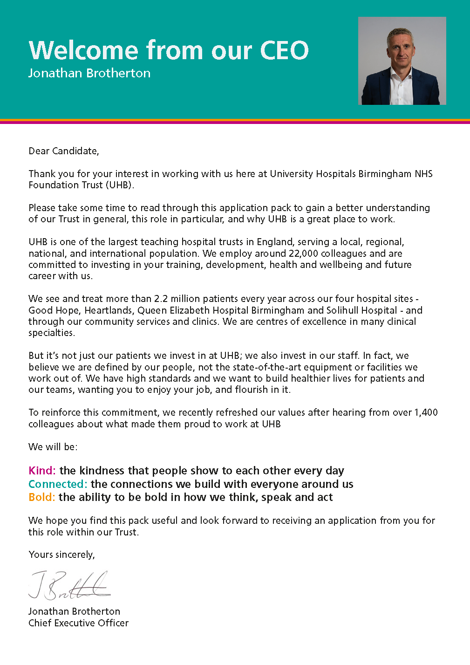

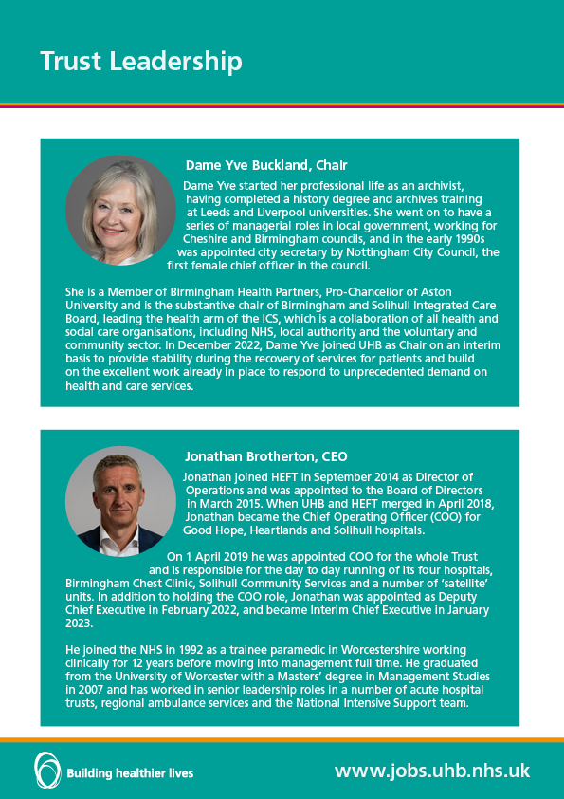
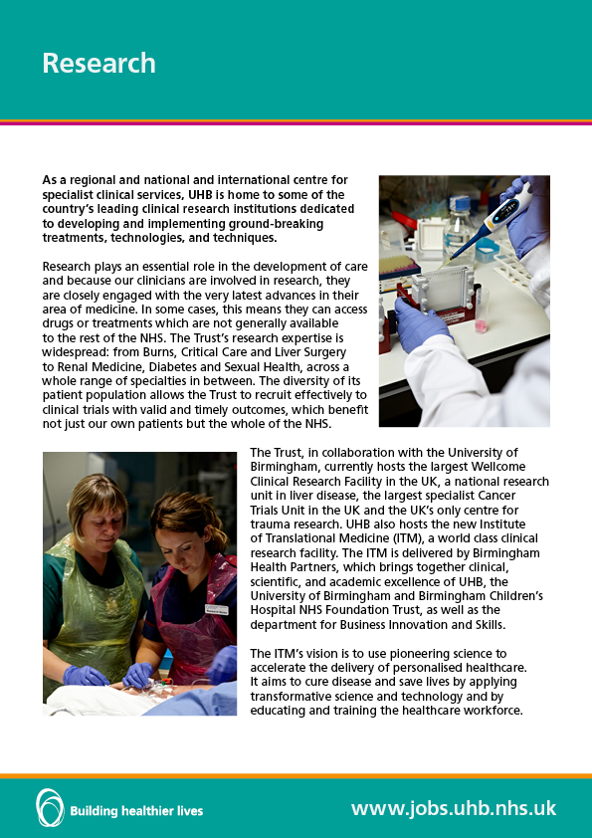
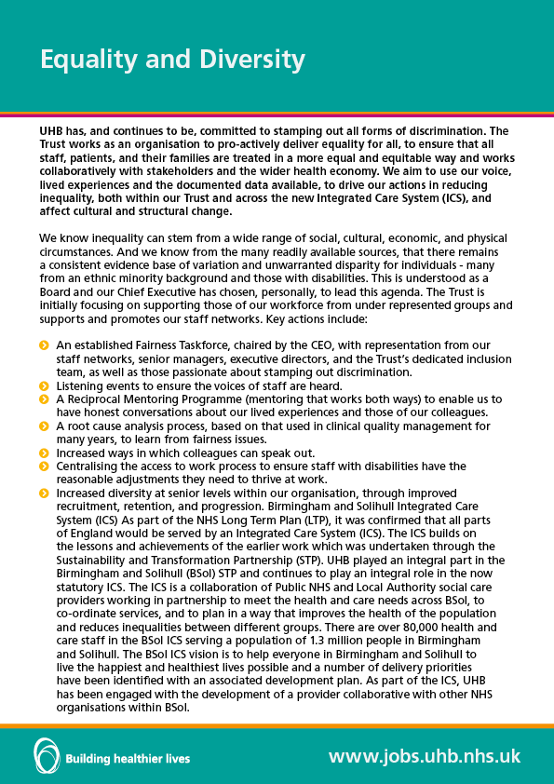
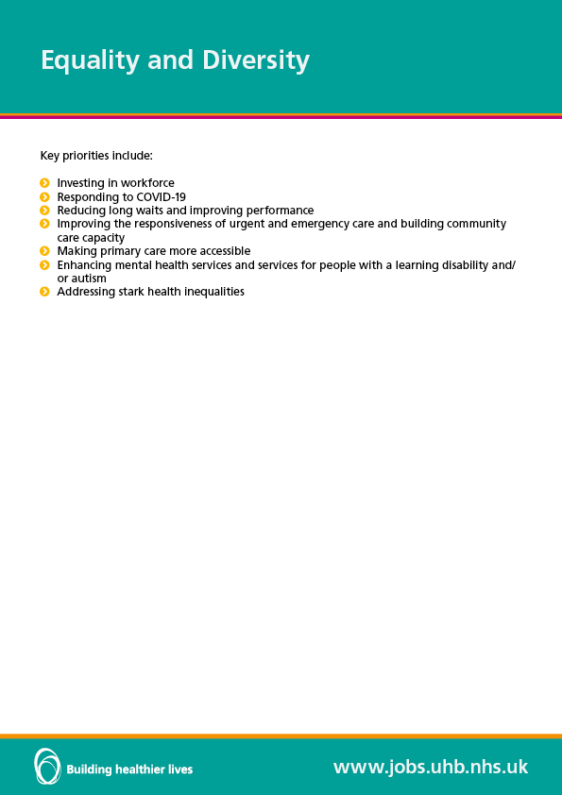
Useful Links
Annual Report and Accounts (uhb.nhs.uk)
Vision, purpose and values (uhb.nhs.uk)
Council of Governors (uhb.nhs.uk)
Strategic aims (uhb.nhs.uk)
Research and innovation (uhb.nhs.uk)
Trust management (uhb.nhs.uk)
Board of Directors (uhb.nhs.uk)
Equality, diversity and inclusion (uhb.nhs.uk)
Caring about healthier lives: NHS Birmingham and Solihull (birminghamsolihullics.org.uk)
Staff benefits (uhb.nhs.uk)

JOB DESCRIPTION

Job Title | Consultant in HIV Medicine and Sexual Health with additional responsibilities for the BBV opt out testing program
Pay Band | Consultant
Department | Birmingham Heartlands HIV Service and Umbrella Sexual Health Service
Clinical Delivery Group (CDG) | CDG 1: HIV and BBV CDG7 Sexual Health
Reports to | Dr Stephen Taylor (HIV /BBV),
Professionally Responsible to | Dr Stephen Taylor, (HIV /BBVs), Dr Penny Goold (Sexual Health)
JOB SUMMARY
The post holder will be one of the HIV consultants delivering the clinical services to the Birmingham Heartlands HIV service with additional responsibilities to the Blood Born Virus testing program. 1 day per week will be working within the integrated sexual health clinics based at Whittall Street Clinic or one of the satellite Sexual Health Clinics. The post holder will be expected to take part in HIV clinical trials research as part of this role.
Acute Medical Sessions maybe available for those individuals accredited in general medicine

TEAM/DEPARTMENT STRUCTURE CHART
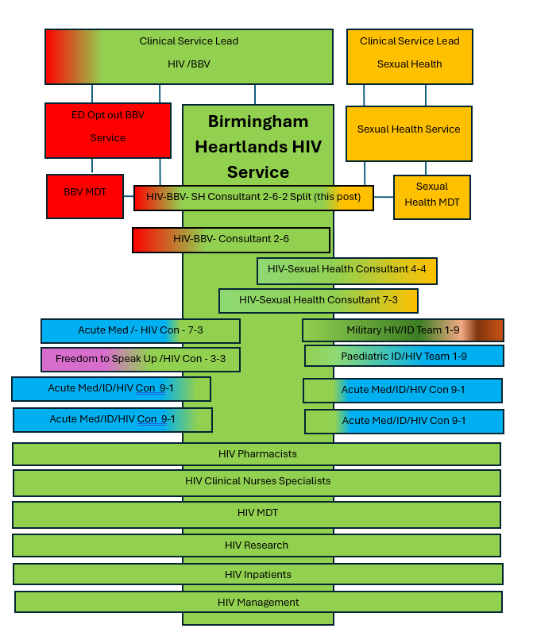

KEY SKILLS
Knowledge / Qualifications

- Full GMC registration and eligible to work in the UK.
- On the speciality register as a GU medicine physician, Infectious Disease Physician or within 6 months of taking up the post.
- Diploma in GU Medicine. (If GU Medicine physician)
- Diploma in HIV medicine.
- DFSRH (Desirable if GU Medicine Physician)

Skills / Experience

- Wide experience in HIV Medicine and GUM
- Experience in Viral Hepatitis: Desirable
- Experience in HIV Clinical Trials: Desirable
- Recent experience and demonstrate ability to provide outpatient HIV care.
- Experience in clinical governance.
- Experience of undertaking and leading on audit projects and service evaluation.
- Experience in teaching and clinical supervision of junior staff.
- Demonstrate leadership skills.
- Able to communicate effectively, in good English, verbally and in writing.
- Work as part of a team and good relationship with colleagues.
- Non-judgemental in attitude.
- Industrious, diligent and reliable.
- IT competent.
- Good organisational skills and time management.
- Experience in undertaking quality improvement projects.

KEY RESPONSIBILITIES
Clinical
- The post holder will become the 4th full time consultant with significant HIV service responsibilities for the Birmingham Heartlands HIV Outpatient service
- They will work with other consultants and MDT within the HIV/Infectious Disease service at Birmingham Heartlands Hospital.
- They will work closely and collaborate with HIV/Sexual Health Consultants at the Queen Elizabeth HIV service
- They will provide Antiretroviral advice to the HIV inpatient service. Inpatient working may be possible depending on clinical experience
- For 1 day per week, they will work with the UHB ED opt out Blood Borne Virus testing program and results management team
- They will undertake at least 2 Viral Hepatitis clinics per month as part of the BBV role. (Experience in management of Viral Hepatitis is desirable but not essential)
- They will support the HIV Research Portfolio. Experience in research is desirable but not essential)
- For 1 day per week they will work within the Umbrella Sexual Health Service
- During this time depending upon previous experience, they will undertake clinics that provide complex and high-quality services in all aspects of sexual health, STI diagnosis and management, of common Genito-urinary medicine presentations, including syphilis, genital and pelvic pain syndromes, genital dermatology contraception and HIV diagnosis.
- This will include adoption and maintenance of best practice guidelines as offered by BASHH, BHIVA, FSRH and NICE, and continuing to enhance service profile and engagement with local, regional and national colleagues, groups and networks.
- Provision of specialist clinical services dependant on service needs and the skills and interests of the individual.
- Assessment and supervision of HIV pre-exposure and post-exposure prophylaxis (PrEP and PEPSE), provision and management.
- Provide clinical advice and support when requested by other primary, secondary and tertiary care services.
- Maintain clinical skills and professional accreditation, to include meeting the CPD requirements of the appropriate professional bodies.
- Contribute actively to MDT meetings.
- Maintain accurate and legible records of clinical work and to use IT as appropriate.
- Complete administrative duties relating to patients’ care such as: dictating letters; reviewing the results of investigations and acting upon abnormal results; dealing with clinical incidents and complaints.

Research

- There is an expectation that the individual will be involved in seeing patients enrolled in the UHB HIV research programme and projects that are in progress within the department

Clinical Governance

- Maintain clinical standards as recommended by BASHH, BHIVA, FSRH and NICE Guidelines.
- Participate in all department and relevant Trust clinical governance activities. This will include clinical audit, quality improvement, clinical incident reporting, risk management, responding to complaints, and all requirements around child and adult safeguarding.
- Support the clinical governance agenda within the HIV service by development of audit, research and evidence-based practice.
- Participate in audit/clinical effectiveness/evidence-based practice and risk management projects as required by the service and for individual revalidation and CPD.
- Develop and update clinical protocols for the service to undertake audits and surveys.
- Develop appropriate research interests that will benefit the clinical service.
- Lead and actively contribute to the audit and clinical research programmes.

Continuing Professional Development

- Participate in all aspects of clinical governance as developed by the Trust to monitor, maintain and develop the quality and effectiveness of care.

- Responsibility for own Continuing Professional development and take part in continuing medical education activities, in line with the requirements of appropriate professional bodies to maintain standards of performance and in consultation with the Service Clinical Lead. The Trust is committed to providing time and financial support for these activities. Study leave is subject to approval by Service Clinical Lead.

- The Trust is committed to the development and maintenance of the highest clinical standards through annual individual appraisal. This will include the audit of personal and clinical practice as well as involvement in departmental and speciality reviews, including multi source feedback. It will also involve attention to continuing professional development and to meeting requirements for continuing medical education as expected by the relevant Royal College. It will also involve the awareness of professional standards and the responsibility to undertake safe and ethical clinical practice and the importance of responding promptly to any circumstances, which may result in increased clinical risk or adverse outcome.

- The appointee is expected to work with cognizance of the latest UK national guidelines in HIV and sexual health, Trust policies, as well as locally agreed guidelines, to attend mandatory training as required by the Trust. Newly recruited Consultants will attend the mandatory Trust induction and be provided with a local induction within the Service. The Trust encourages new consultants to work with a mentor and will support consultants with this.

Appraisal & Revalidation

- There is an expectation to maintain appropriate records such that the General Medical Council will grant successful revalidation of fitness to practice at the appropriate time.

- All consultants are expected to participate in annual appraisal. The Trust has the required arrangements in place to ensure that all doctors have an annual appraisal with a trained appraiser and supports doctors going through the revalidation process.

BUDGETARY AND RESOURCE MANAGEMENT
- Training can be provided in post

MANAGEMENT, SUPERVISORY, TEACHING, TRAINING RESPONSIBILITIES
Leadership / Management

- The post holder:
- Will have the opportunity to take up responsibilities from the following areas:
  - Clinical leadership for the Birmingham Heartlands HIV service
  - Clinical leadership for the UHB opt out BBV service
  - Further development of the Birmingham Heartlands HIV research agenda
- Will work with the service clinical lead, Trust colleagues, commissioners regarding any service changes and developments.
- Will provide professional leadership for medical staff within the service, including responsibility for appropriate induction and mentoring of new medical and MDT staff, appraisal, clinical supervision and input into ongoing professional and personal development of medical and MDT staff.
- Will undertake clinical supervision of the HIV and BBV MDT teams and provide clinical supervision to senior HIV pharmacy and Clinical nurse specialists.
- Work with departmental consultant colleagues to coordinate any external teaching and training required.
- The post holder will have additional areas of responsibility as agreed with the Clinical Service Lead.

Education and Training

- Involvement in the teaching and training of departmental staff and other areas within the Trust including other specialities and primary care is an expected part of this role.
- Educational supervisor and clinical supervision of trainees within the department. Clinical supervision of other trainees within the department.
- Provide teaching, advice, support and supervision of nurses, pharmacists and other members of the MDT team
- Support and contribute to the professional development of medical, nursing and other staff, as appropriate.

RESEARCH AND DEVELOPMENT
The Birmingham Heartlands HIV service has an active Research and Development program and has been involved in HIV strategy and treatment trials since the early 1990’s. The service continues to be research active and is currently running 5 international HIV antiretroviral treatment or prevention trials

The post holder is expected to take up an active role in support and provision of the clinical care of patients enrolled into these studies. The post holder will become a sub-investigator on each of the trials running in the department. They will be encouraged develop their own research interests within the fields of HIV treatment, management, prevention or public health. There are good links with researchers at the University of Birmingham and Warwick. The research team includes medical staff, research nurses, a project manager

EFFORT
Will be determined by application, interviews and references

TRUST VISION & VALUES
The Trust is clear on its vision and values and aims to make sure that they are reflected in all areas of activity. Our vision is simple, building healthier lives. Our values apply to every member of staff and help us in all we do and how we do it. They are:

Kind: The kindness that people show to each other every day
Connected: The connections we build with everyone around us
Bold: The ability to be bold in how we think, speak and act

ADDITIONAL INFORMATION
This job description is designed to assist post holders with understanding what is expected of them in their role. University Hospitals Birmingham NHS Foundation Trust may ask them to undertake other duties, as required, which are not necessarily specified on the job description, but which are commensurate with the grade of the post.

The job description itself may be amended from time to time in consultation with the post holder, within the scope and general level of responsibility attached to the post.

All post holders must take responsibility to ensure that they are aware of and adhere to all Trust policies, procedures and guidelines relating to their employment regardless of their position within the Trust.

Last Updated: 12-2-26

Example Job plan

The Job plan will be discussed and mutually agreed with the Clinical Service Lead for the service.

Day | Session | Location | Work | Category | PA’s
Monday | am | BHH | HIV Clinic | DCC | 1
Monday | pm | BHH | Viral Hepatitis Clinic /BBV Role | DCC | 1
Tuesday | am | BHH | HIV Clinic | DCC | 1
Tuesday | pm | BHH | SPA | SPA | 1
Wednesday | am |  | Late start
Wednesday | pm | WSC | Management Meetings  Once per Month HIV Cross site meetings and regional MDT  GUM Clinics | SPA  DCC | 0.25  1
Wednesday | Evening | WSC | GUM clinic | DCC | 0.75
Thursday | am | BHH | HIV clinic | DCC | 1.0
Thursday | pm | BHH | HIV MDT Alternate weeks  HIV Admin Alternate weeks  Management meetings  Flex DCC | DCC  DCC  SPA  DCC | 0.25  0.25  0.25  0.25
Friday | am | BHH | HIV MDT Alternate weeks  HIV admin alternate weeks  Flex DCC | DCC  DCC  DCC | 0.25  0.25  0.5
Friday | pm | BHH | BBV Role | DCC | 1
 |  |  | Total | DCC | 8.5
 |  |  |  | SPA | 1.5
 |  |  | Total |  | 10

DCC 8.5 PA

Clinical administration (including letters, referrals, results, handling of clinical incidents and patients' complaints), travelling time.

Supporting professional activities (SPA) 1.5 PA

Including: teaching, training, consultant meetings, service development, audit and quality improvement. This includes joint consultants meeting 2nd Wednesday each month at 2-4pm.

Participating in a Saturday GUM on call rota is off set by taking a day in lieu midweek

PERSON SPECIFICATION

Consultant in HIV Medicine and Sexual Health with additional responsibilities for the BBV opt out testing program
TRAINING, QUALIFICATIONS AND PROFESSIONAL REGISTRATIONS
ESSENTIAL | DESIRABLE
- Full GMC registration and eligible to work in the UK.  - On the speciality register as a GU medicine physician, Infectious Disease Physician or within 6 months of taking up the post.  - Diploma in GU Medicine.(If on GUM Specialty Register | - Highly Desirable: Diploma in HIV medicine.  - DFSRH
EXPERIENCE & KNOWLEDGE
ESSENTIAL | DESIRABLE
- Wide experience in GUM and HIV medicine.  - Recent experience and demonstrate ability to provide outpatient and HIV care.  - Experience in clinical governance.  - Experience of undertaking and leading on audit projects and service evaluation.  - Experience in teaching and clinical supervision of junior staff. | - Experience with Viral Hepatitis outpatient Clinics  - Interest in HIV /GU Research  - Completion of research and / or quality improvement projects.  - Presentations in conferences and / or publications in peer reviewed journals.  - Specific training and qualifications in teaching; GMC accreditation as clinical and / or education supervisors.  - Recent experience and demonstrate ability to provide inpatient HIV care.
SKILLS & ABILITY
ESSENTIAL | DESIRABLE
- Demonstrate leadership skills.  - Able to communicate effectively, in good English, verbally and in writing.  - Work as part of a team and good relationship with colleagues.  - Non-judgemental in attitude.  - Industrious, diligent and reliable.  - IT competent.  - Good organisational skills and time management.  - Experience in undertaking quality improvement projects. | - Experience in using electronic patient record systems.  - Attendance of management courses.  - Demonstration of leadership e.g. leading projects to a successful completion.  - Training in appraisals and clinical supervision.
OTHER SPECIFIC REQUIREMENT
ESSENTIAL | DESIRABLE
- Strong service commitment, flexibility of work location and able to work at all University Hospital sites.
- Able to work late clinics until 7 pm and Saturdays on a rotational basis

